M I L B O U R N E
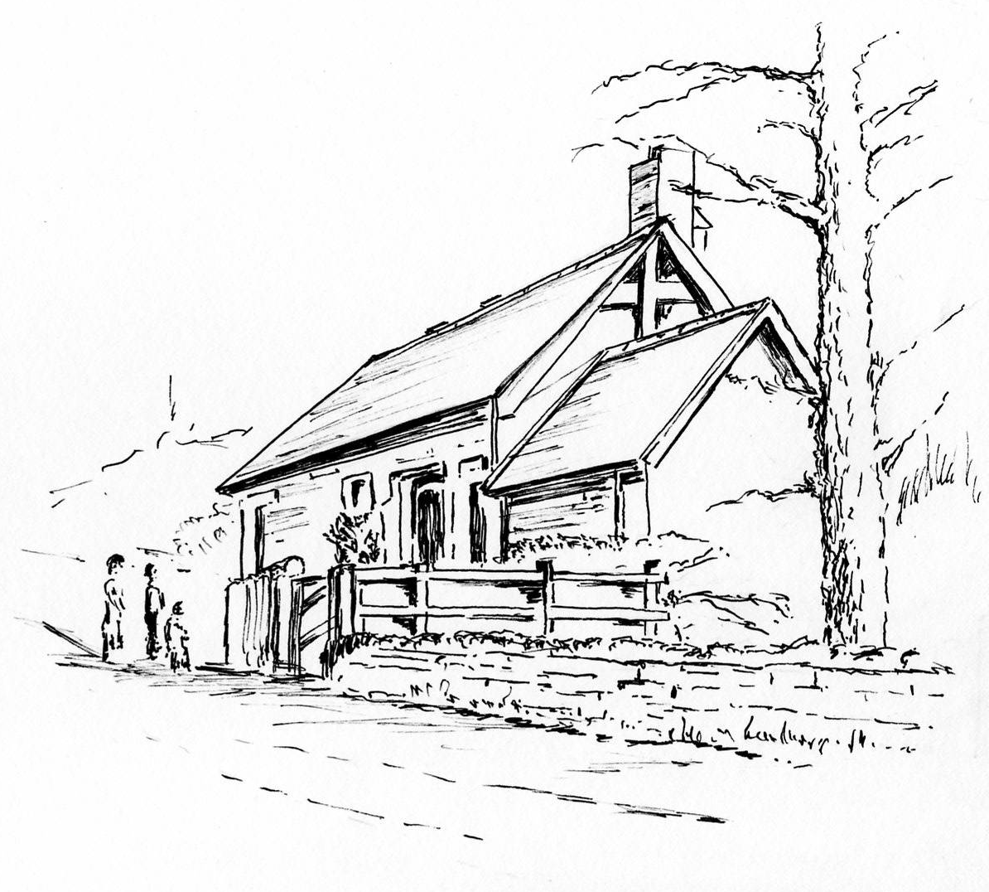
E
T
H
O
D
I
S
T
Notices for Sunday
20 November 2022

Sunday before Advent
Jeremiah 23:1-6, Colossians 1:11-20,
Luke 23:33-43.
If you want to speak to our minister, Deacon Maggie Patchett, she can be contacted directly by telephone (01661 854073).

Minister: Deacon Maggie Patchett, 20 Aquila Drive, Heddon on the Wall, NE15 0BS

Church Notices.
Sunday 20th November -6.30pm.
Preacher -Deacon Maggie Patchett.

Sunday 27th November -6.30pm.
Preacher -Peter Hindle.

Sunday 4th December -6.30pm.
Preacher -Rev Keith Albans.

Tuesday 6th December -7.00pm.
Bible Study in the chapel.

Friday 9th December -7.00pm for 7.30pm.
Ponteland Golf Club – Christmas Meal.

Sunday 11th December -6.30pm.
Preacher –Rev. Tim Woolley (S).

Sunday 18th December -6.30pm.
Carol Service led by Estwar Sanichar.

Saturday 24th December -11.15pm.
Christmas Eve Service led by Rev. Tim Woolley.

Sunday 25th December – Christmas Day
NO SERVICE

Saturday 31st December – 11.30pm.
New Year’s Eve Service – Pat & Robin Brooks.

